Drodzy Rodzice,
Poniżej znajdują się ćwiczenia.

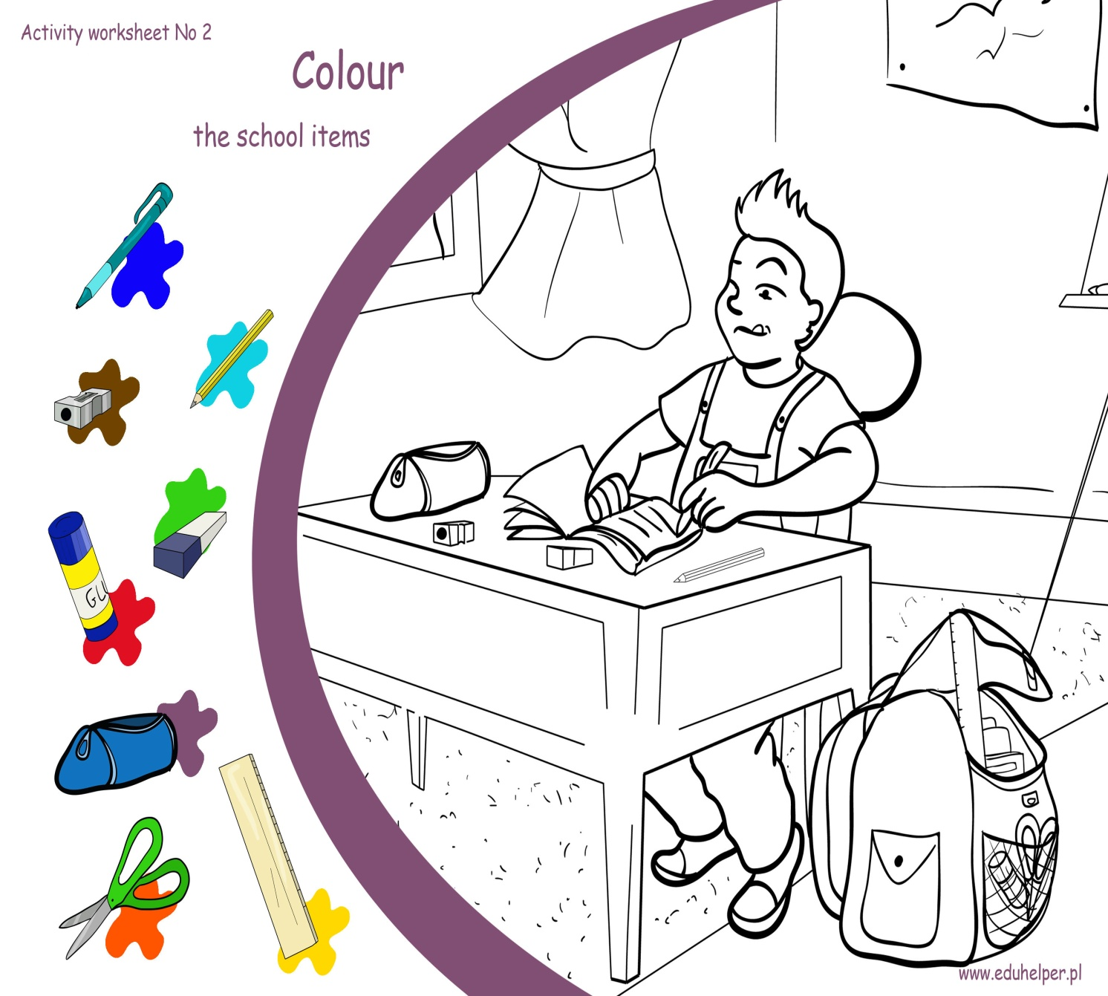

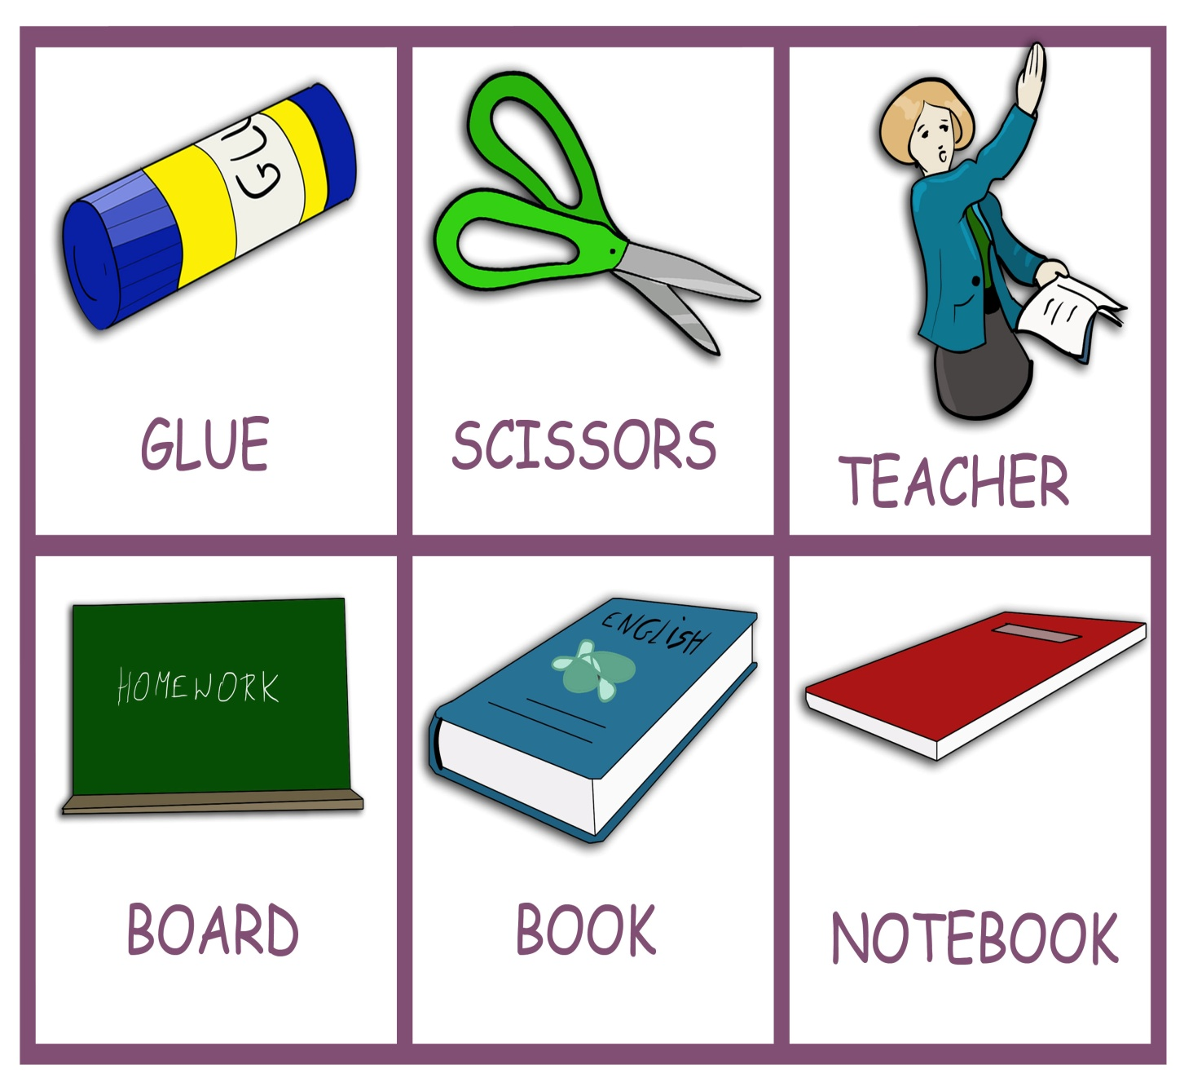

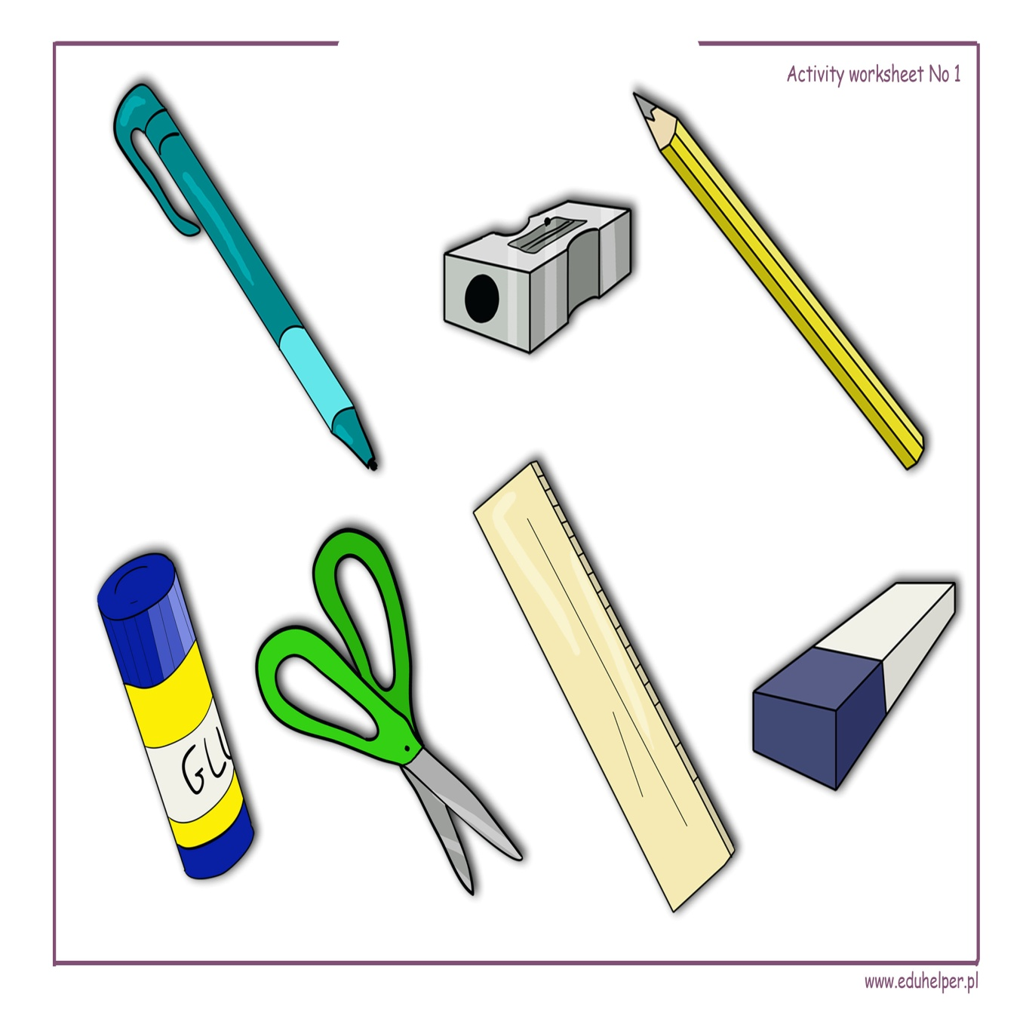

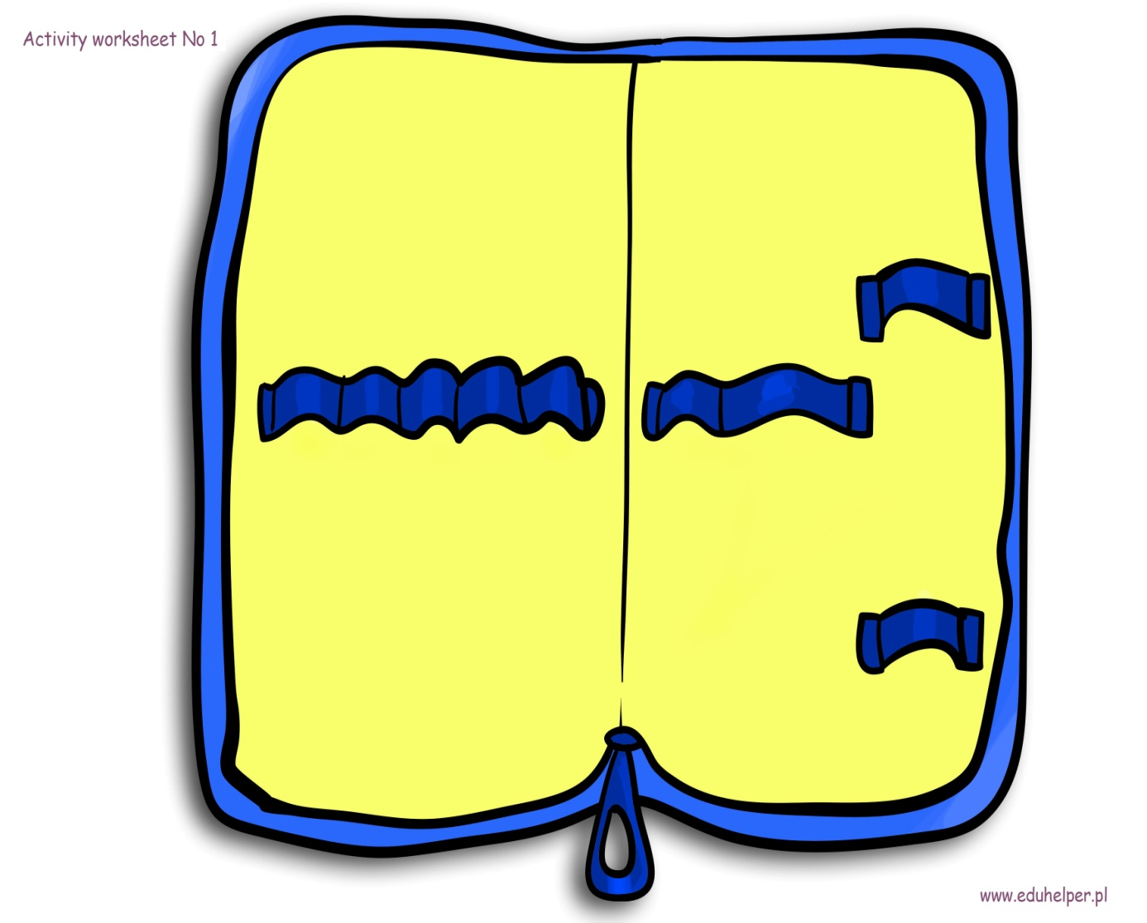

Fragment bajki w j. angielskim „Strażak Sam”

https://www.youtube.com/watch?v=KzSamG3CwLU

Piosenka
https://www.youtube.com/watch?v=BwBTozQisb4
I have a pencil. What do you have? X 3
Put it in my bag I have a ruler. What do you have? X 3
Put it in my bag I have a notebook. What do you have? X 3
Put it in my bag I have a marker. What do you have? X 3
Put it in my bag I have a stapler. What do you have? X
3 Put it in my bag I have a paper. What do you have? X 3
Put it in my bag What do you have
I have – ja mam
Put it In my bag – włóż do mojej torby

