Słowniczek:

It’s sunny – jest słonecznie

It’s rainy- jest deszczowo

It’s windy – jest wietrznie

it’s cloudy- jest pochmurno

it’s a thunderstorm- jest burza z piorunami

Słuchamy:

<https://www.youtube.com/watch?v=pHxHsgONGus>

<https://www.youtube.com/watch?v=P9abGg_gF1s>

<https://www.youtube.com/watch?v=Jn7uAsLWXpk>

What's the weather, What's the weather,

What's the weather like today?

All together, All together,

What's the weather like today?

Look it's windy, Look it's windy,

Look it's windy, everyone.

Fly a kite, Fly a kite,

Fly a kite, everyone.

Look it's rainy, Look it's rainy,

Look it's rainy, everyone.

Jump in the puddles,

Jump in the puddles,

Jump in the puddles, everyone.

Look it's sunny, Look it's sunny,

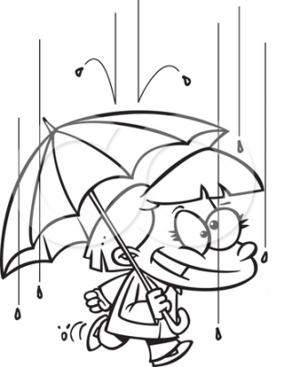Match the weather picture with the right situations!

**sunny**





**cloudy**





**rainy**

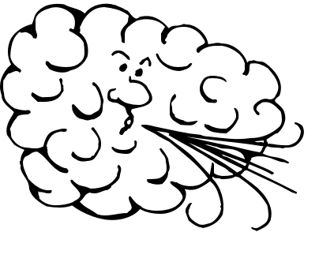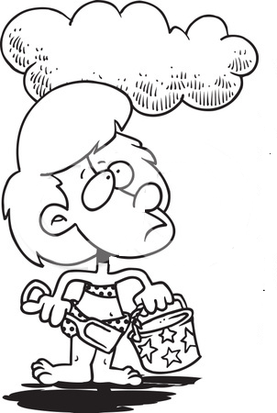

windy

Wycinamy i dopasowujemy do rysnuków ☺

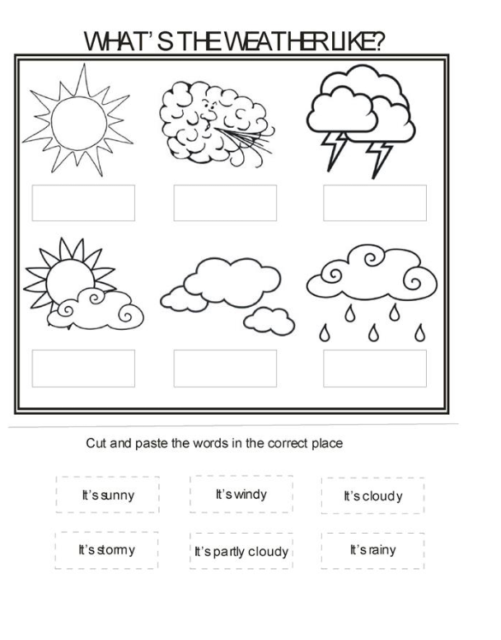

Zaznaczamy ubrania, które nosimy gdy świeci słońce i kolorujemy.

